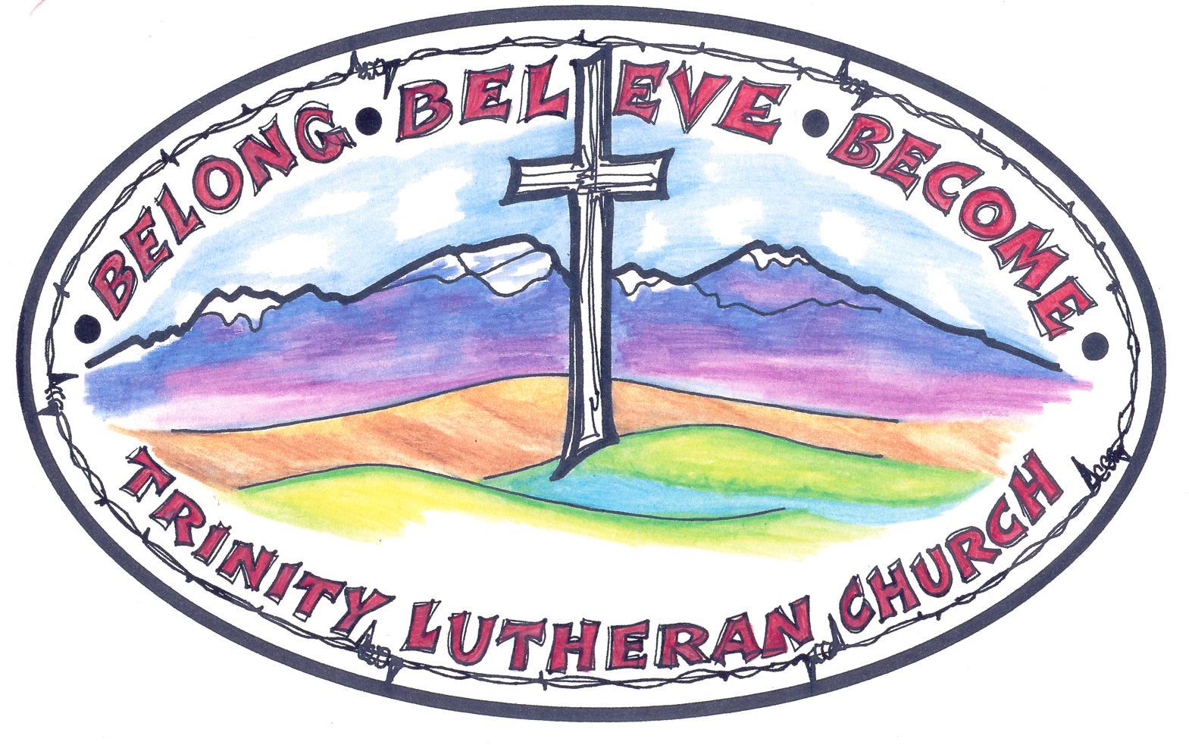

Dear Scholarship Applicant,

Thank you for applying for a scholarship from Trinity Lutheran Church.

Things to consider:

- The scholarships are only available for High School Seniors who are members of Trinity Lutheran Church.
- The scholarships are for the second semester of the first year only.
- The application must be typed and can be downloaded off of the TLC website:
www.choteautlc.com.
- In any given year, all of the scholarship funds may not be awarded.
- The determination of scholarship awards will be made by the Scholarship
Committee and the Trinity Church Council.
- The Scholarship Committee will be made up of one church Council representative and two at large members.
- The scholarship application must be into the church office (dropped off or by mail) by the due date listed on the 2nd page of the scholarship application

All scholarships are payable at the beginning of the second semester of the freshman year provided the student has successfully completed the first semester. Any special circumstances must be brought before the Scholarship Committee; the committee’s decision is final.

Sincerely,

The Trinity Lutheran Church Council

38 First Ave. SW, PO Box 110 Choteau, Montana 59422
(406) 466-2291

TRINITY LUTHERAN CHURCH SCHOLARSHIP APPLICATION

Eligibility: 1. Open to all High School graduating seniors who are members of Trinity Lutheran
Church.
- There are no restrictions as to field of study, but the institution must be accredited or licensed
in the state where it is located.

- Applicant’s name _________________________________
Last First Middle initial

2. Home address Phone

City State Zip

3. Date of birth Place

4. High school attended

Location Graduation year

Cumulative grade point average to date

5. Principal high school activities, offices held

- Describe any non-school (ex: community service, church activities) related activities in which you have participated.

_______________________________________________________________________________________
_______________________________________________________________________________________

_______________________________________________________________________________________

_______________________________________________________________________________________

_______________________________________________________________________________________
7. Institution you plan to attend _________________

8. Proposed field of study

9. Intended career or vocation

10. How do you plan to maintain your Christian faith while in college & in your chosen career?

_______________________________________________________________________________________

- How has Trinity Lutheran Church impacted your life? __________________________________________

_______________________________________________________________________________________

_______________________________________________________________________________________

_______________________________________________________________________________________

_______________________________________________________________________________________

- What is the most important contribution you have made to your church? ___________________________

_______________________________________________________________________________________

_______________________________________________________________________________________

_______________________________________________________________________________________

_______________________________________________________________________________________

Deliver or mail this completed application to the church office by May 15, 2015. Recipient must notify Trinity Lutheran Church Scholarship Committee by August 1, 2015 if their intent is to decline the scholarship. Check will be made payable to the institution.

Trinity Lutheran Church
38 1st Avenue SW
P.O. Box 110
Choteau, MT 59422-0110
Phone: 1-406-466-2291
Email: choteautlc@yahoo.com

